**Topic Name:**

The main aim of this lab session is to provide hands-on experience on

* Getting Help
* Basic Commands
* Navigation
* File System
* simple shell script

1. Getting Help

|  |  |  |  |  |
| --- | --- | --- | --- | --- |
| Task | Command Name | Syntax | Example | Screenshots |
| To get manual page for the known command | man | man command_name | man ls |  |
| To get manual page for the unknown command | apropos | apropos keyword | apropos bash |  |
| To know the source file binary | whereis | whereis command_name | whereis ls |  |
| To know the path of the command | which | which command_name | which ls |  |
| To know the command is external or internal | type | type command_name | type pwd |  |
| To get help for the internal command | help | help command_name | help pwd |  |
| To list out bash commands | compgen | compgen -b | column | compgen -b | column |  |
| To know the usage of the command | info | info command_name | info pwd |  |

1. **Basic Commands**

|  |  |  |  |  |
| --- | --- | --- | --- | --- |
| Task | Command Name | Syntax | Example | Screenshots |
| To know today’s date | date | date | date |  |
| To print calendar | cal | cal [ [ month ] year] | cal 05 2024 |  |
| To print kernel version | uname | uname -option | uname -r |  |
| To print default shell | echo "$SHELL" | echo "$SHELL" | echo "$SHELL" |  |
| To print currently logged in user | who | who [options] [filename] | who |  |
| To create shortcut for command | alias | alias shortcut = “command” | alias c="clear" |  |
| To delete shortcut | unalias | unalias [-a] [alias_name(s)] | unalias c |  |
| To change the timestamp of the file | touch | touch [Option] [File] | touch -t 2301011536 example.txt |  |
| To clear the screen | clear | clear | clear |  |
| To create empty files | touch | touch filename | touch myfile.txt |  |
| To know disk usage | df | df -option | df -a |  |
| To know free space in the system | df | df -option | df -i |  |
| To know about the Linux release | cat | cat /etc/os-release | cat /etc/os-release |  |

1. **Navigation**

|  |  |  |  |
| --- | --- | --- | --- |
| Task | Command | Syntax | Screenshots |
| To navigate home directory | cd | cd |  |
| To navigate to the parent directory | cd .. | cd .. |  |
| To navigate to the child directory | cd dirName/*/. | cd dirName/*/. |  |
| Alternate command to cd | pushd | pushd dirName |  |
| To go back to the previous directory | cd .. | cd .. |  |
| To go to the root directory | cd | cd |  |

1. **File System**

|  |  |  |  |
| --- | --- | --- | --- |
| **Task** | **Syntax** | **Command** | **Screenshot** |
| **How to identify the file system** | **df -Th** | **df -Th** |  |

1. Create Folder “CYS”
2. Navigate to CYS
3. Create folder LS1 and LS2 under CYS
4. Go back to CYS
5. Working with Files
6. Add commands which you learnt during lab session in the file commands.txt
7. Change the timestamp of the file to yesterday
8. Copy the contents from the file commands.txt to commands_demo.txt
9. Rename the file commands_demo.txt to duplicate
10. Rename all .html to .hldd
11. Delete the file duplicate
12. Copy the contents commands.txt to unit4 and unit5 (using relative path)
13. Delete the contents from unit5 (using absolute path)
14. Navigate to root
15. List all the files under root
16. Explore all the folders (Do not delete any folder)
17. Navigate to /etc/passwd
18. Open the file passwd
19. Explore the file passwd
20. Navigate to /etc/group and explore

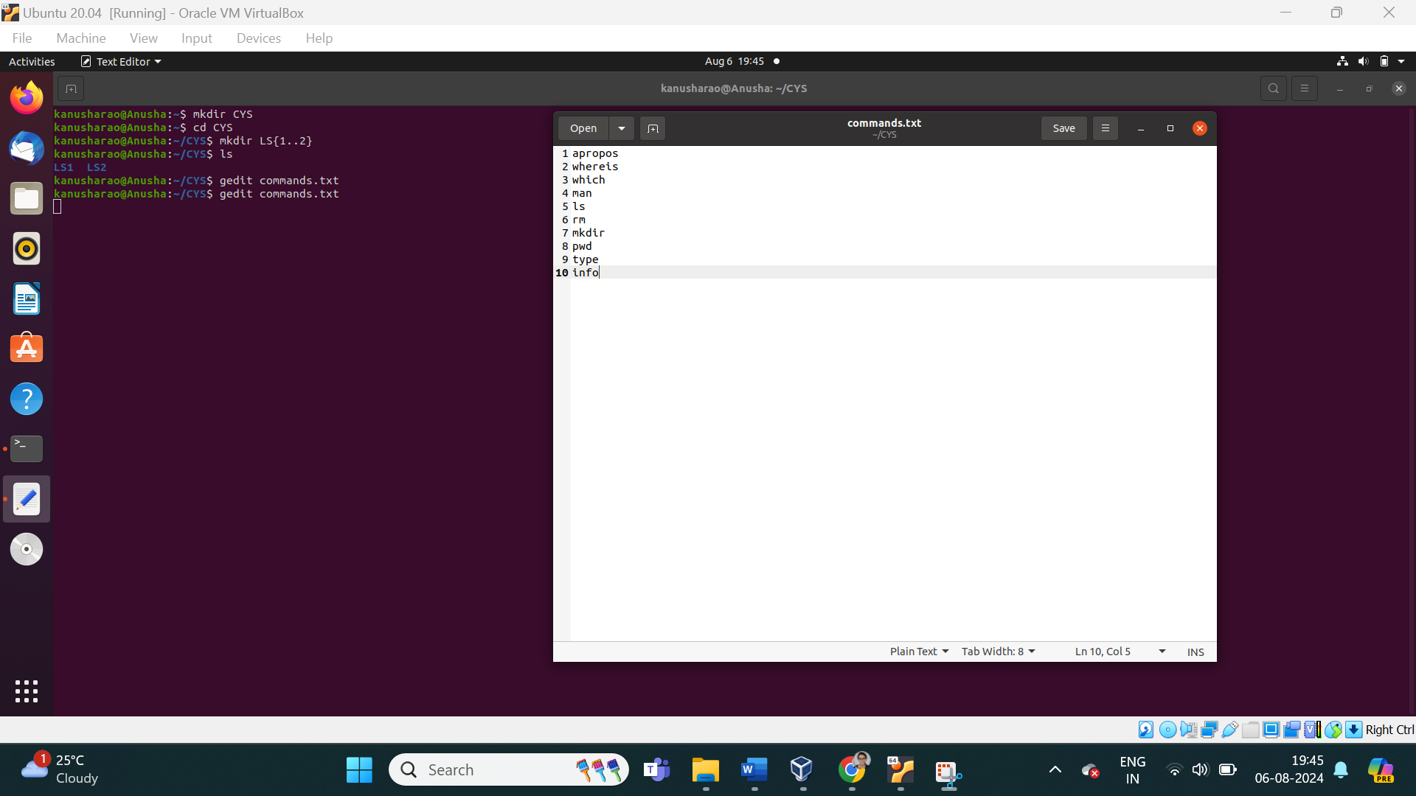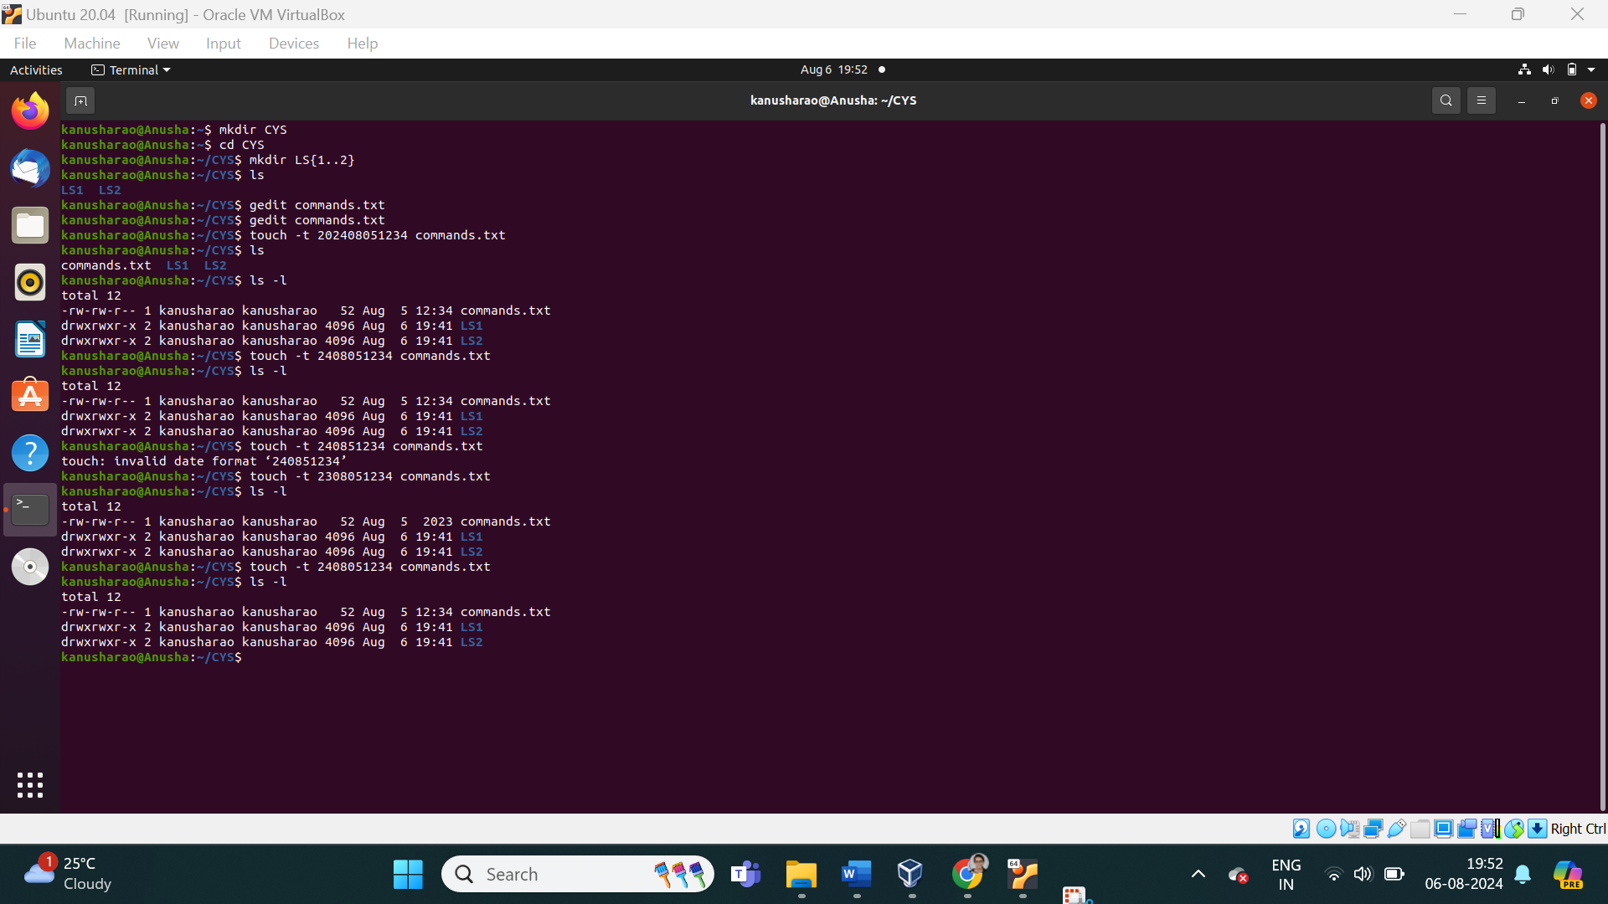

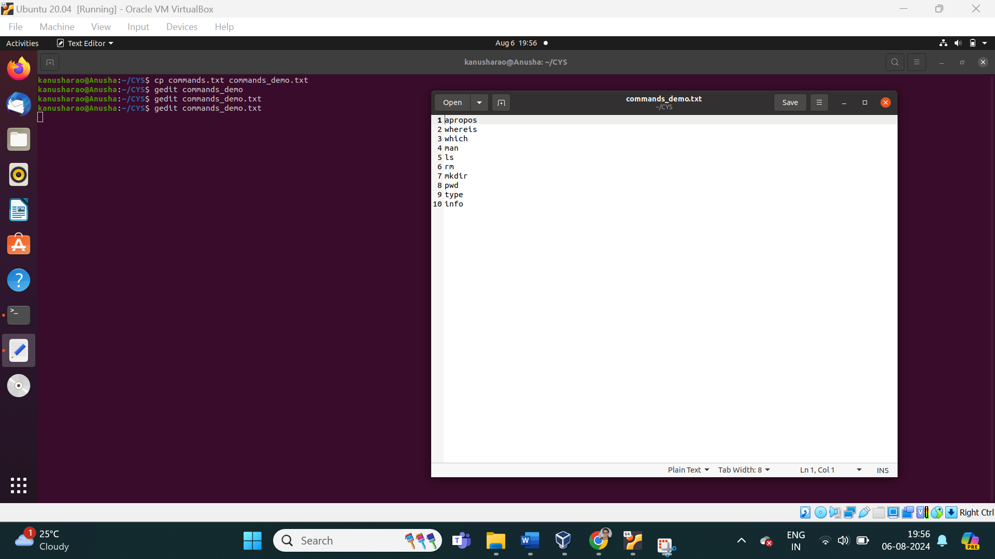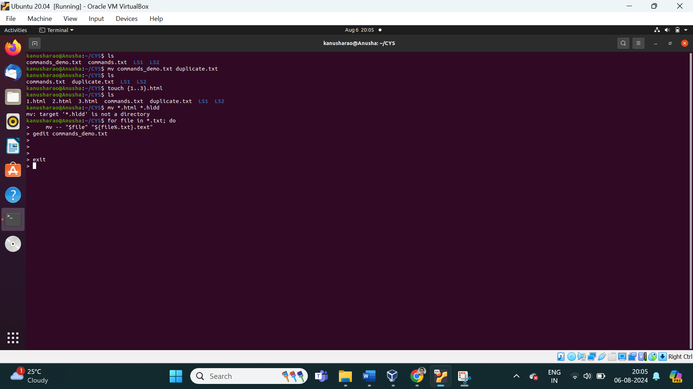

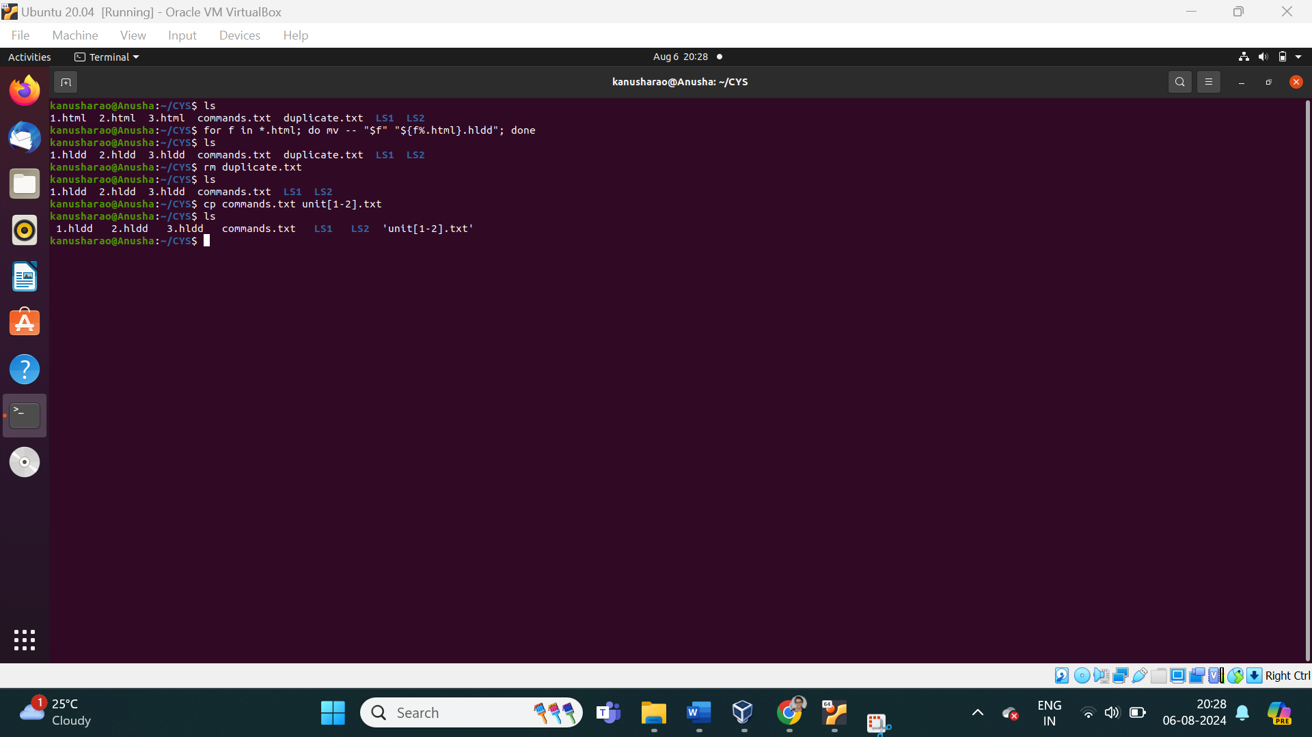 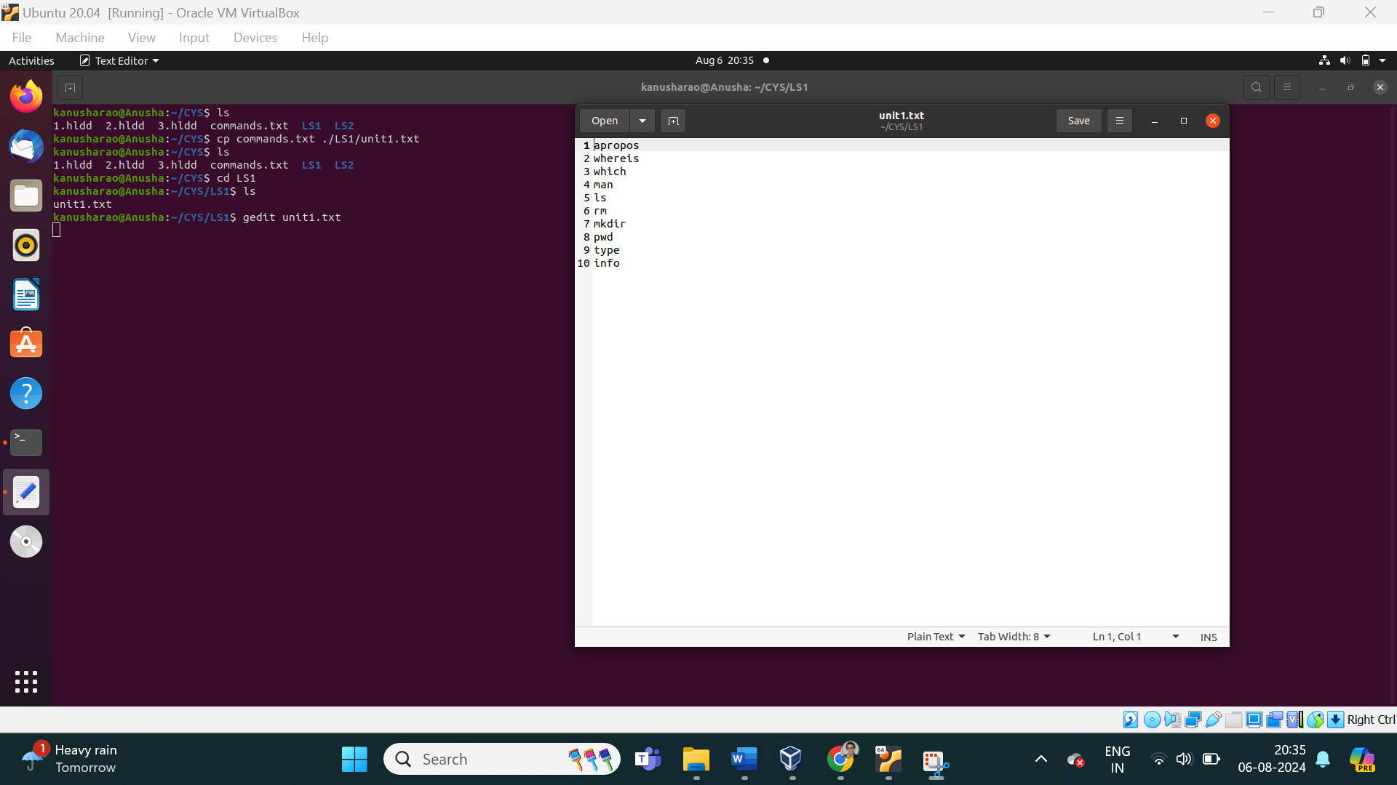

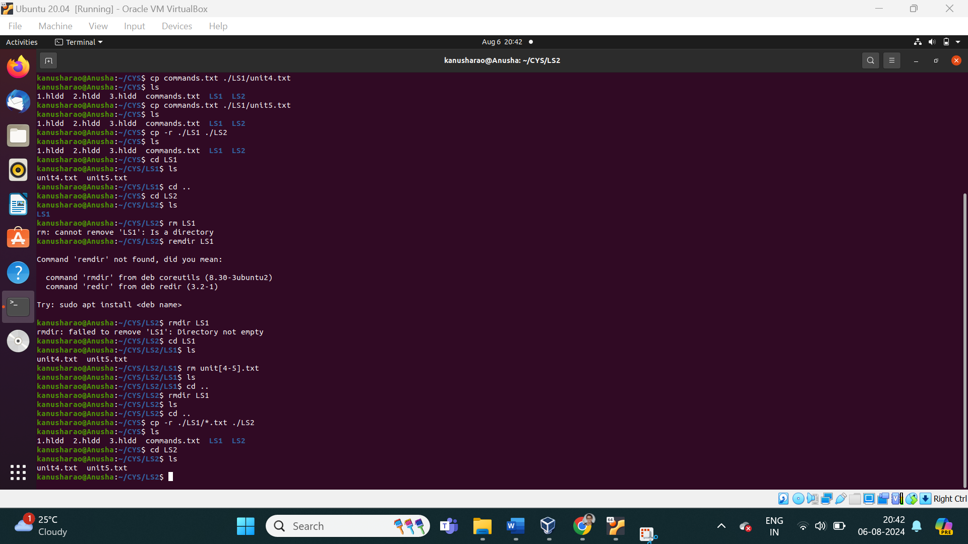 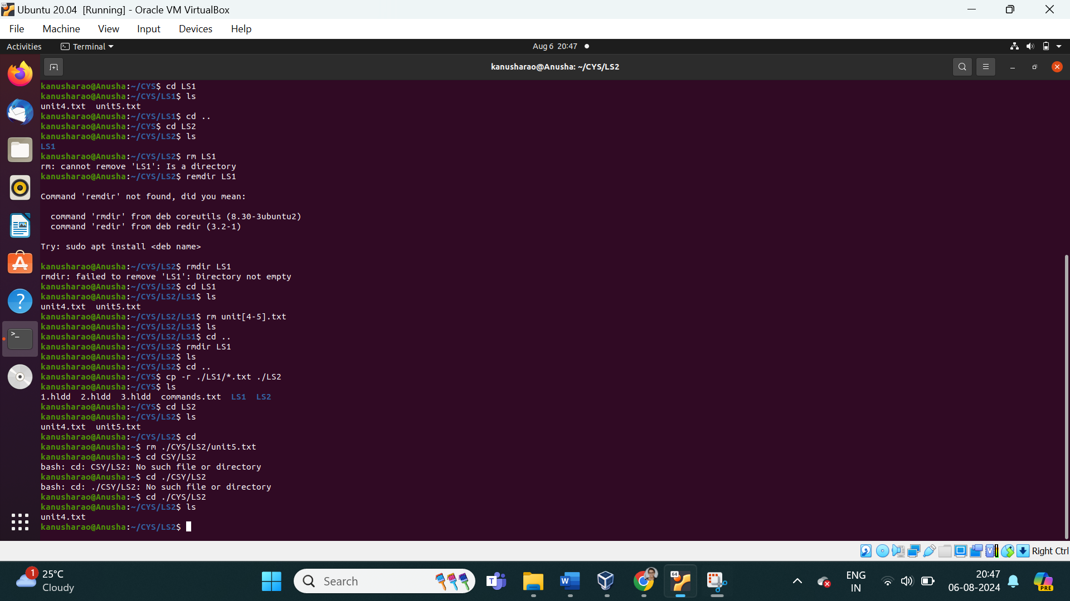 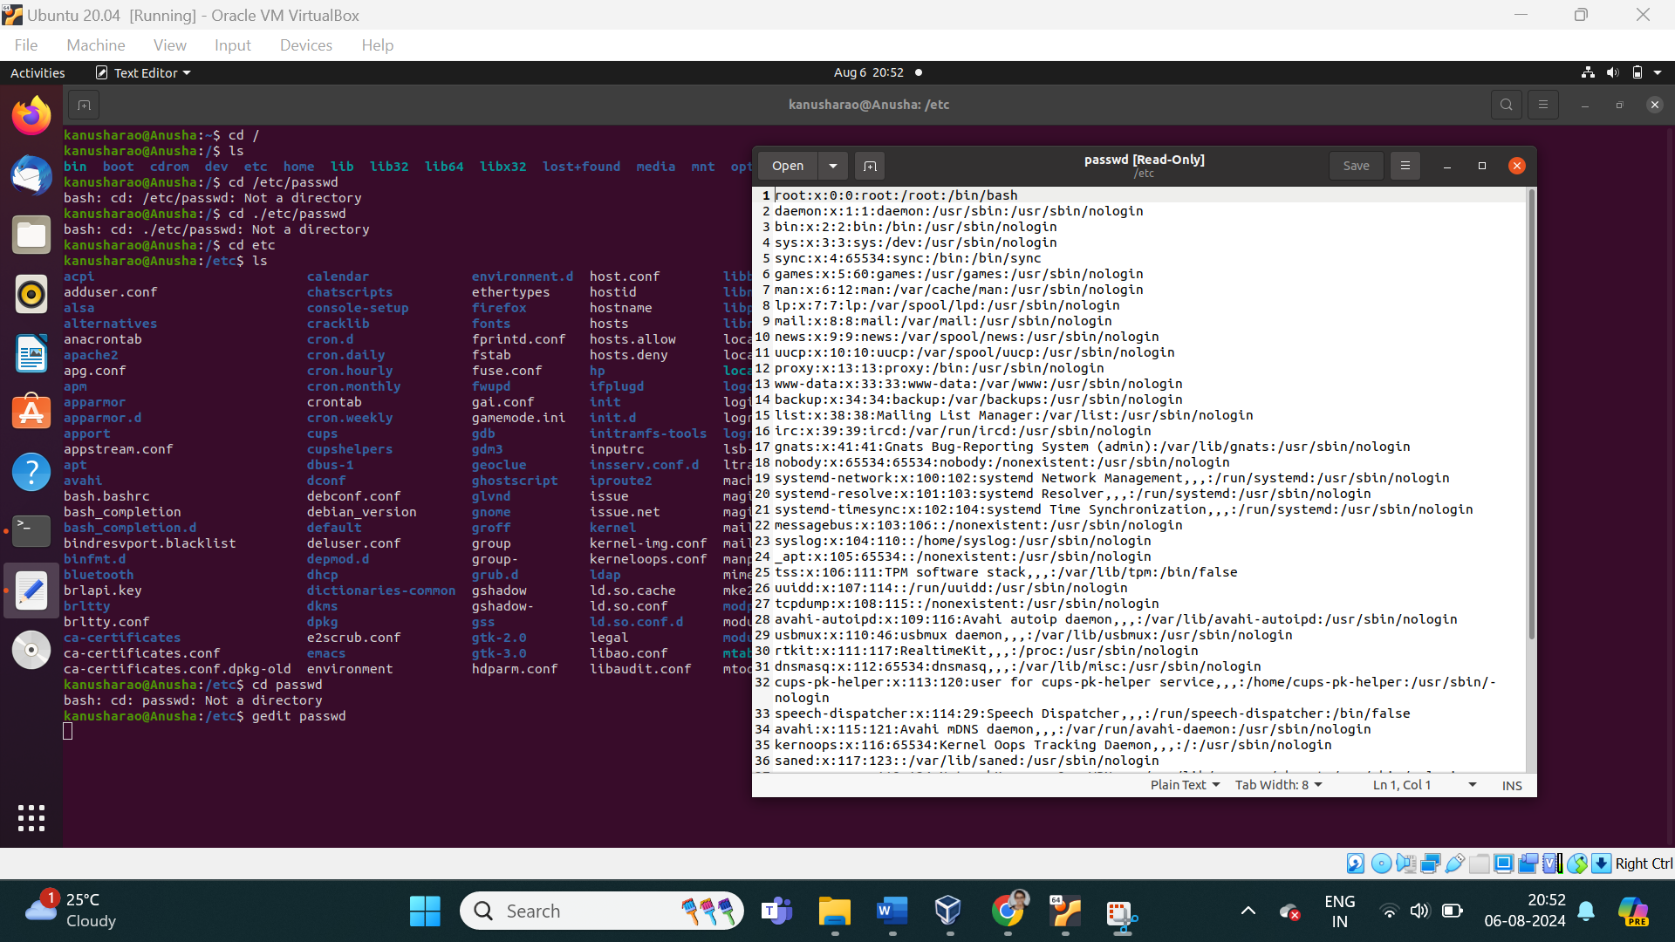 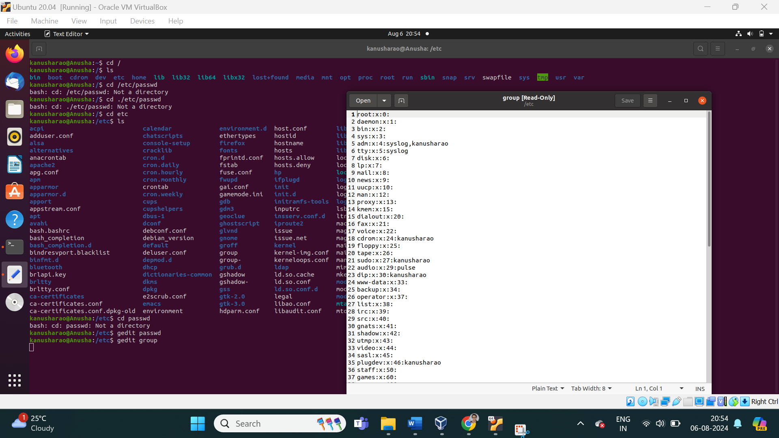

1. **Difference between** 
   * + 1. GUI vs. CLI

|  |  |
| --- | --- |
| **GUI** | **CLI** |
| Consuming more memory. | It consumes low memory. |
| GUI operating system needs both a mouse and keyboard. | CLI operating system needs only a keyboard. |
| GUI, the information is shown or presented to the user in any form such as: plain text, videos, images, etc. | CLI, the information is shown or presented to the user in plain text and files. |
| GUI does not provide the facility to script a sequence of commands. | CLI enables a user to simply script a series of instructions to carry out a task or execute a program. |

* + - 1. man vs info

|  |  |
| --- | --- |
| **man** | **info** |
| The man command is used to display the manual pages for various commands, system calls, library functions, and more. It provides a structured and concise reference for command usage and options. | The info command provides access to the GNU Info documentation system. It is used for reading documentation about GNU software and other related topics. Info documentation tends to be more detailed and hierarchical compared to man pages. |
| Organized into sections such as NAME, SYNOPSIS, DESCRIPTION, OPTIONS, etc. | Info pages are organized in a hierarchical structure with menus and submenus, allowing for more detailed documentation. |

* + - 1. which vs. whereis

|  |  |
| --- | --- |
| **which** | **whereis** |
| The which command is used to locate the executable file associated with a command in the directories listed in the $PATH environment variable. It shows the full path of the executable that will be run when you type a command. | The whereis command locates the binary, source, and manual page files for a command. It provides a broader search, including locations where the command’s related files might be found. |

* + - 1. Terminal vs shell

|  |  |
| --- | --- |
| **Terminal** | **shell** |
| A terminal is a physical or virtual interface that allows users to interact with a computer system. It is often referred to as a terminal emulator when used in a graphical environment. | A shell is a command-line interpreter that provides a command-line interface (CLI) for users to interact with the operating system. It processes user commands, executes them, and returns the results. |

1. Write a simple shell script to print your name and your hobbies!

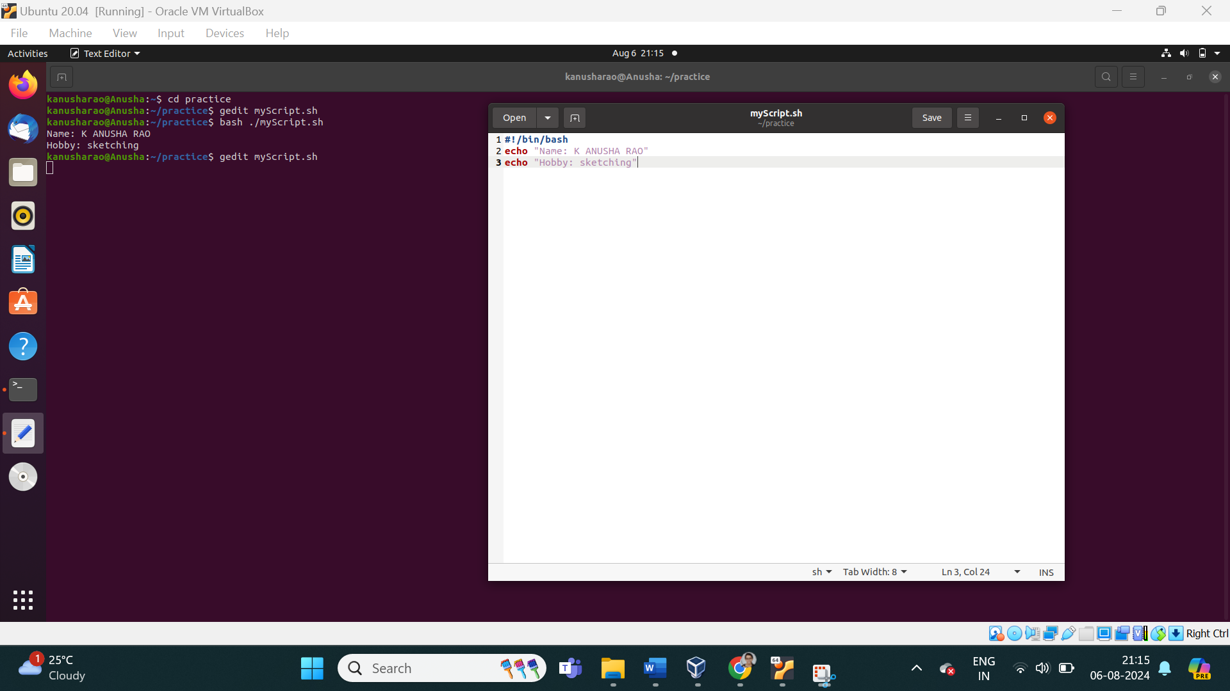

**Interesting commands to Explore**

Banner

History

**Note:** Include your screenshots

Evaluation :

Marks : 10 (Deadline : 4 – Originality :3 – Completeness :3 )

Deadline: 06.08.2024

“All our dreams can come true if we have the courage to pursue them.”

Walt Disney